PHOTOSHOP TIMELINE ANIMATION
This lesson teaches you how to use the Timeline function in Photoshop CS6 (the Animation Panel in Photoshop Extended CS5) to create an animation. It’s FUN! You load the drawings you’ve created for your animation into layers, load them into the Timeline and voila! An animation.

It works well all on its own as a simple tool for creating animations or as a quick way to check your drawings for more complex animations. Explore and enjoy! THIS is empowering.

My students are studying animation very specifically but - you could be creating an animation for virtually any subject. That is what makes this such a 21st century tool. It allows you to bring media literacy, digital literacy and visual literacy and storytelling into your classroom.

THE PRODUCTION PROCESS
- Create your animation drawings / images. We scan in hand drawn images on paper. You might create these digitally.
- Scan in the pictures and clean them up (remove dust spots, fix errors)
- Add COLOURS!! Make them fun and alive. I know – my samples are black and white, intentionally. They serve my class’s needs. You do what works for your project.
- We have several drawings up on each sheet of paper – see the examples at the end of this document. If this is your process, then now is a good time to cut them apart so each image is on its own layer, and all images are in a single document. To do this....
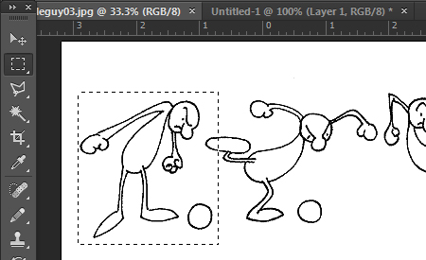
- First I suggest masking the first image – as shown, and Ctrl C to copy

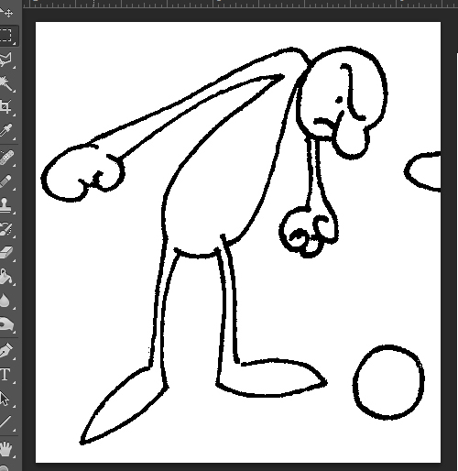
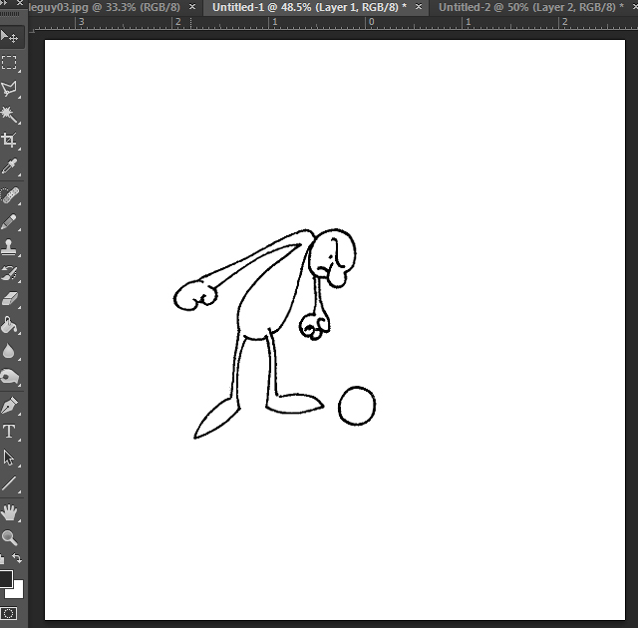
- Then go to File – New – and click OK. A white screen will pop open. Then Ctrl V to paste. You now have the single image as its own document. Before adding the other images you must first resize this image’s canvas to be sure that the other pictures will fit together. My character needs vertical and horizontal space for his moves so... I resized this canvas to be much larger in width and height. In this example the single images were around 2.5” x approx. 2.5”. I resized the canvas up to 6” x 6” so it looks like this...
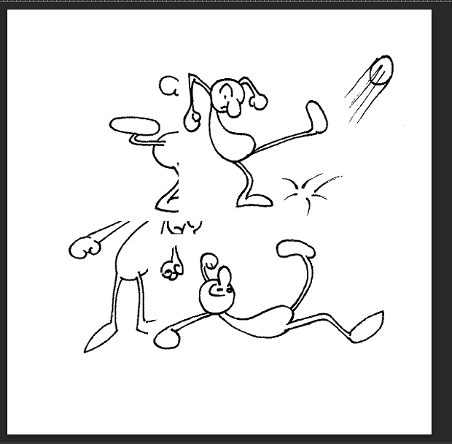
- Next – go back and mask each image separately and copy and paste from the original sheet onto this new document. This puts all the action images together into one document, with each image on its own layer. This is a MUST! Now then – it looks like a mess! It’s okay – we’ll sort it out.

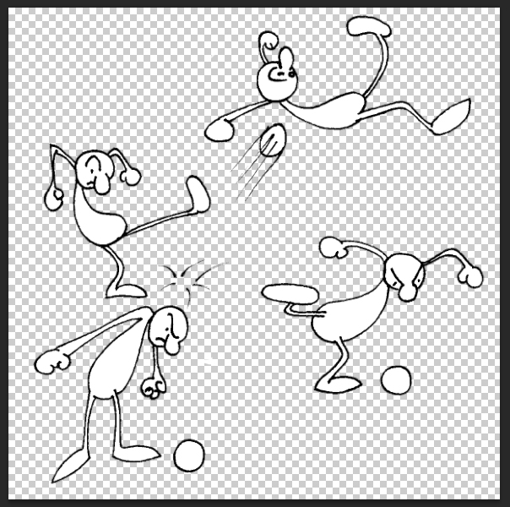
- Once each drawing is on its own layer I recommend removing the white area around each figure. I use the Magic Wand with the Tolerance set for 8 to grab all the white around the drawings. Be careful! If there is a break or a hole in the drawings’ outlines then you’ll erase some of their fill – not cool. Be sure to touch up the outlines by using the Pencil tool – easy and quick.

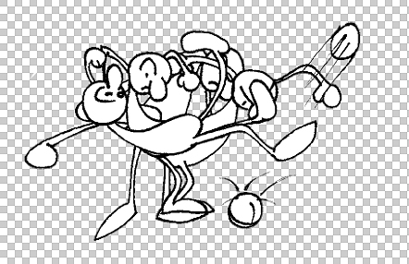
- Now - align the layers so each image is located where you think it needs to be to perform properly in the animation. If the positioning is doubtful, don’t worry. You can change it completely later in the process. Having it close now just saves you time later. See the screen cap to understand.

- In CS6, be sure the Timeline panel is open. I could tell you all the details of how to do the next steps but I would simply be repeating one of the very helpful instruction sheets from Adobe. Go to http://help.adobe.com/en_US/photoshop/cs/using/WSB8C58284-9DEB-44f2-9D8F-7F77594A8CC2a.html and follow their directions. They work, with the following bits to help you along...
- First – be sure to properly prepare your layers
I strongly recommend re-labelling each layer so it’s correctly numbered from 1 - ?? That way every layer will have a number and that number will be correspond exactly with the frame number in the Timeline. THIS HELPS SO MUCH> take the time to do this so all layers are in the correct order and correctly numbered, in perfect sequence.
Next - this part drove me nuts! I read the instructions and could not figure out how to load the carefully prepared layers images into the Timeline....
first, be sure you have set the Timeline for Create Frame Animation (there are only two choices)
then – click the button clearly labelled, Create Frame Animation! I know – so obvious. But I missed it and you might, too. In either case, now you know...
- When choosing the “Delay” ie: the timing function, I started by using 0.2 seconds, which worked quite well. You’ll experiment and see what works best for you.
- Creating the correct sequence of frames / layers can be a pain in the ....... BE PATIENT. It works Following the directions they offer works but you have to be so careful.
Select frame 1. Then select Layer 1. Frame 1 will automatically sync to Layer 1
Select frame 2, then Layer 2, and so on. Do this carefully.
ALSO – be sure that only the layer you want is turned on – you’ll quickly see how confusing it gets when multiple layers are turned on. Easy to fix – just stay calm and patient.
- Save your project as a .psd file, with all layers, etc.
- To check your animation just use the Player buttons so neatly provided, and enjoy the results of your work.
- To create this as a movie – go to File – Export – Render Video.
A settings dialogue box will appear – since it offered H.264 MP4 as its first choice (there are others) and it works well for me in most applications, I just went with the default settings. You will do what works best for you and your circumstances.
Click OK and let it render and then enjoy your project. I hope it worked out well.

ADDITIONAL THOUGHTS / IDEAS
Since the images are in Photoshop already, why not use the tools there to help create additional images for your animation. In my case I duplicated several images and used the masking tools to isolate my character’s arms onto new layers, revised their shape and position by using Edit – Transform – Rotate and Edit – Transform – Warp.
I also recommend experimenting with the Tween functions to help build smoother motions and effects. These are covered in Adobe’s instructions – very cool.
NOTE – If you are scanning hand drawn images may I recommend...
- do the “sketching” (rough drawing) in either light blue (best) or light gray. Keep it LIGHT.
- THEN – go over the sketches and ink in the real outline for each image using a good BLACK pen – medium width. Too thin tends to disappear, too fat looks awful.
- Set your scanner to scan in Black and White, not grayscale, not color. The scan will be cleaner and clearer.
- But – Photoshop will see this as a purely black and white image and will pevent you from adding colors, etc. Easy to fix. Go to IMAGE – Mode – change it to Grayscale. THEN – do it again and change it to RGB – now you’ll be ready to add color and do whatever else you require. This somewhat convoluted process gets you cleaner scans ready to go. Scanning in, either as grayscale or color, will tend to capture every little dust spot and sketch nuance every created and you’ll waste too much time trying to clean them up.

This is the original set of drawings for the animation, all up on one sheet. As you can see, there are other images here as well. I like doing this because it maximizes every scan.
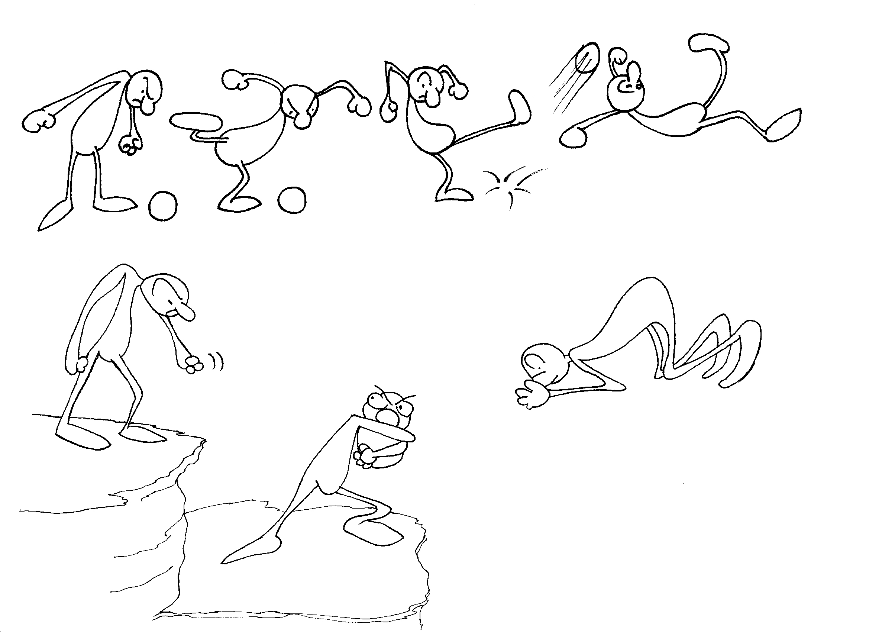

This series shows how my one drawing of the character slipping up into the air was rotated and then revised to show him falling and then landing (ouch!). I did this using the Edit – Transform tools mentioned above. Make your characters expressive – it really helps to bring them to life.
The original drawing... rotated... modified once... and again...
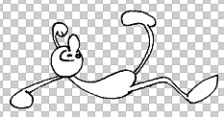
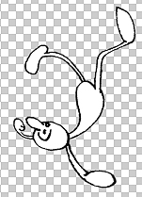
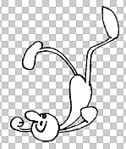
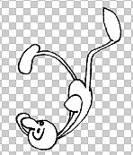

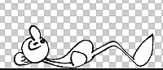
and then yet again for his landing. All from the same original drawing. This process is much faster than redrawing all of the frames normally required and gives you great creative control over the work. You should also explore the Effects and Filters tools.

